# Topological Sort (TS)

You must read about DFS before this to understand.

To do TS the graph must be acyclic, which means no loops.

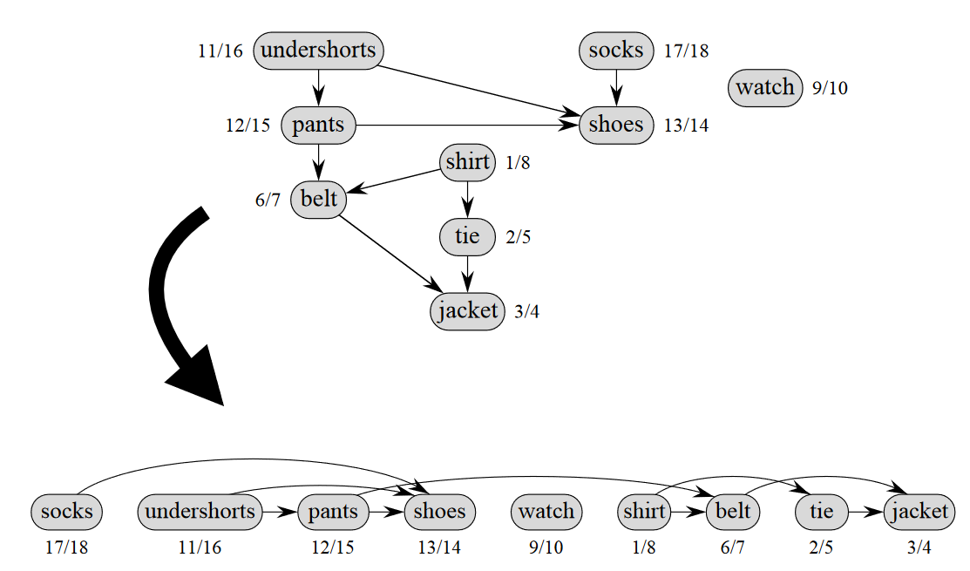

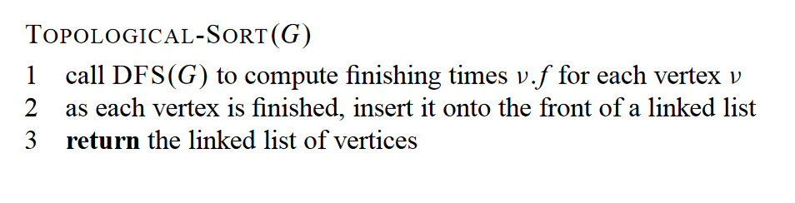

Its important to note that it’s a linked list, where there are pointers to predecessors and children.

